Economic Analysis of GIS-aided Conservation Planning

Travis James Killen
Dr. Gary Kronrad
Dr. Daniel Scognamillo

Project Goal
The goal of this project is to utilize GIS technology as a tool to economically reduce deforestation and destruction of jaguar habitat zones in accordance with regulations passed in Argentina and the Province of Misiones (Law XVI – No. 106).

Project Objectives
1. Use GIS to find sites for plantations that will serve as alternative sources of firewood for industrial firms currently consuming firewood from native forests.
2. Perform an economic analysis and determine investment strategies at each location.
3. Display results in a web-based GIS system.

Justification
Many of the justifications for this project are outlined in the Regulatory Framework for Renewable Dendroenergetic Resources (Law XVI – No. 106). The law is intended to reduce deforestation for fuelwood consumption in native forests, among other objectives. While this effort preserves natural resources in Argentina, it will likely cause stress to local communities and businesses dependent on those resources. This project will focus on how tea dryers are affected by these new laws. Tea dryers represent one of many different businesses that could use the methods and results outlined in this project.
Argentina is not self sustaining in forestry products. (Datamonitor 2010, p. 46) The province of Misiones harbors almost 40% of Argentina's biodiversity and produces over 70% of its timber (Montagnini 2006, p.53) The largest remnant of Atlantic Forest remains in Misiones, but is declining due to agriculture, cattle grazing, and forestry activities. (Izquierdo et al. 2006) Between 1973 and 2006, 4689 km² of natural forest cover was converted to other uses, representing a decrease from 65 to 49% forest cover for the whole province. (Izquierdo et al. 2006, p. 5)
To alleviate these problems, this project will combine information and technology into a web application that industry can use to find sites for plantations and analyze the costs.

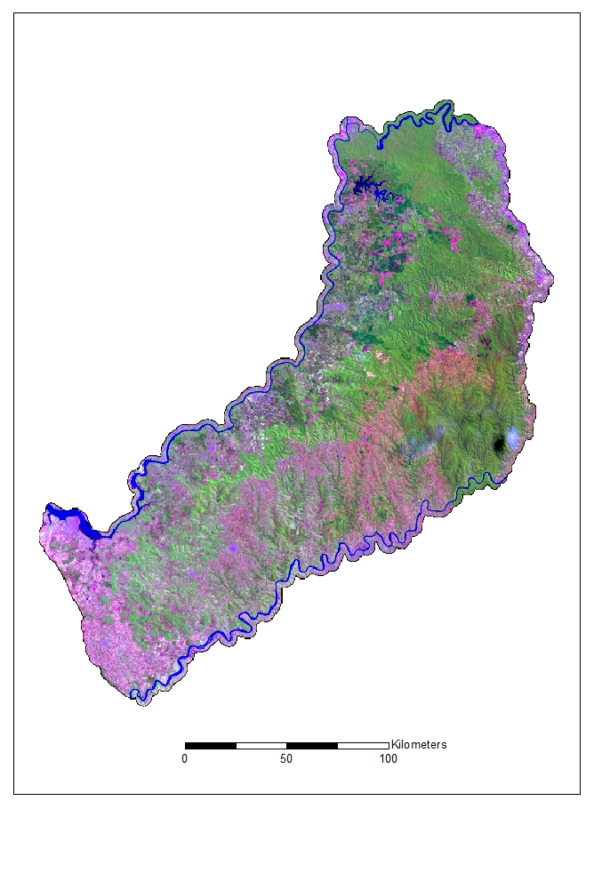
Literature Review
Understanding Misiones
Tea dryers are among those affected by this regulatory framework because wood used in the tea drying process. Similar to tea, yerba mate is cash crop (Montagnini 2006, p.54) and a very popular beverage in Misiones. The locals in this province drink yerba mate like tea in England or coffee in the United States. Yerba mate plants begin to produce at 5 years and reach full production at age 9. The leaves are hand-picked from the plant when they are mature. After harvest the leaves are transferred to a dryer where they are exposed to heat. Fires burn day and night as the leaves tumble in the dryer. One dryer, "Las Marias" consumes 6 tons of wood per day. The drying process takes about 3 to 4 hours per load. Once the mate is dried it is first crushed and then transported and stored for 6 months. It is during this time that the mate develops its characteristic flavor, aroma, and color. After milling and packaging the leaves are steeped in hot water (not boiling) and shared with friends. (Gilson Berger, pers. comm., National University of Misiones, Apr. 12 2011)
Currently much of the wood used in the process is consumed from native forest land in the Interior Atlantic Forest. The Renewable Dendroenergetic Resources Regulatory Framework states that all mate and tea dryers must reduce their consumption of firewood by 50%. Figure 1 shows a false color composite map of the Province of Misiones and outlines the Interior Atlantic Forest. The map was derived from four 2009 Landsat 4/5 Thematic Mapper satellite images available for download from the U.S. Geological Survey website. (glovis.usgs.com 2011) The Landsat images were chosen for their similar temporal resolution and low cloud cover. The imagery was mosaicked in ERDAS using a histogram match. A few clouds blemish the Southeast quadrant.
The resulting product displays the Interior Atlantic Forest in green. Dark green areas are plantations and agriculture is both pink and bright purple. Urban areas are pink and gray, but are difficult to distinguish from agriculture on this map. Cities are mainly in the Southwest and along the rivers that border the country.
Argentina has developed a land cover map that categorizes land in Misiones into one of three zones. Red zones represent protected native forest land with high diversity levels. Yellow zones are native forest that can be managed sustainably for hardwoods, fruits and other products. Green zones are forest land that is so degraded that you can cut the cover and change to another sustainable use. (Santiago Cuevas, pers. comm., National University of Misiones, Mar. 21 2011)
Figure 1. A false color composite map of Misiones, Argentina.
Using GIS
GIS has been used successfully as a planning tool for many different spatially explicit forestry problems. GIS has been used to investigate the connection between timber supplies and sawmills (Harouff et al. 2008), analyze distribution of wood utilizing industries (Adewopo 2010), evaluate forest road network design (Chung et al. 2008), and study demography and deforestation in the Brazilian Amazon (McCracken et al. 1999). One study was used plan forest and conservation activities in Southeast Asia (Webb 2002). This study was particularly interesting because it addresses problems very similar to current concerns in Misiones. Webb integrated social preference into the GIS model which resulted in refined polygons and more usable plantation site locations.
Remote Sensing will be used in this project to determine land cover types. Remote sensing is the practice of deriving information about Earth from a distance using the electromagnetic spectrum. (Campbell 2002, p. 6) Since different objects on the Earth reflect different spectral signatures, we can use the information to learn about the study area. Our accuracy assessment will provide the ability to quantitatively compare methods and use derived data in a decision making process (Congalton 2001). The accuracy assessment methods used in this project are outlined by Russell G. Congalton.
Economic Analysis
Recognition of the time value of money can make a significant difference in the long-term impact of capital budgeting decision. (Weygandt et al. 2005, p. 495) Net present value (NPV) is defined as the difference between net cash flows discounted to their present value and the capital outlay required by the investment (Weygandt et al. 2005). Net present worth or present worth (NPW) may be substituted for NPV during the scope of this project.

Methods
GIS aided site planning
Figure 2 illustrates a conceptual work flow model demonstrating the fundamentals of this project. This is not a working GIS model. The model will require the use of three raster and two vector layers. A point location will be identified on the map by the end user. The point can be anywhere in the study area. This location represents a business in need of plantation firewood. We will define a 25 km buffer around the point and define the area as suitable. A transportation layer will show land areas accessible by roads. Close proximity to a road is a necessity for harvesting timber at low cost. We will buffer the roads by 5 km and identify the area as suitable.
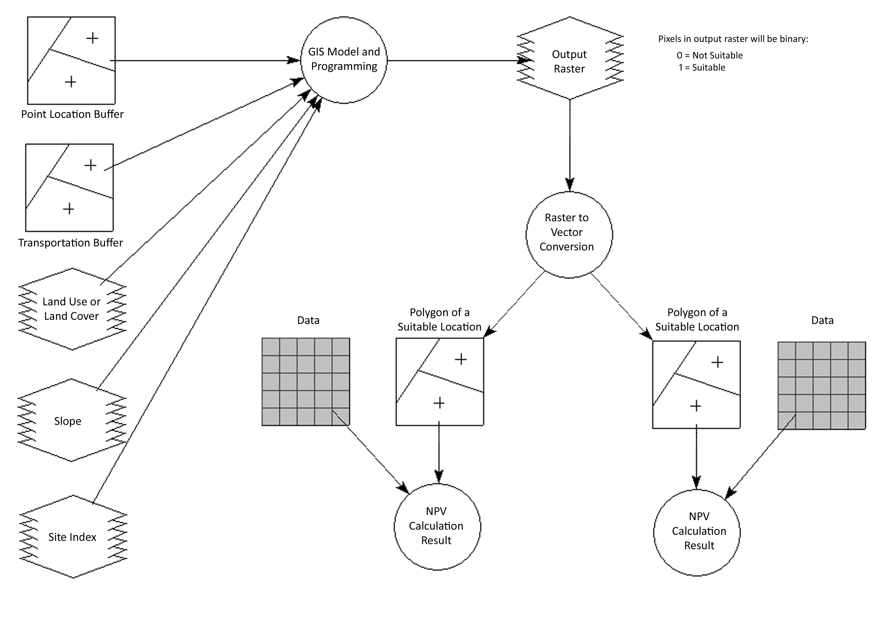
A land use and land cover map layer will provide information of land most suitable for plantations. A land cover map will be derived from the 2009 Landsat Thematic Mapper satellite images outlined earlier in the project. We will use an unsupervised classification and start with 150 classes. The classification will run with a 99% convergence threshold and will meet the threshold before the maximum iterations. The image will be classified in to the following categories: water, forest, plantation, agriculture, and urban. A land use map will also be used in the model and will be provided by Argentina. Yellow and green zones will be marked as suitable.
A slope map will be used to discount areas that are too steep for plantations. The slope map will be derived from Digital Elevation Models using a slope analysis in ArcGIS. A site index map will also be used to identify suitable pixels. The model will search for appropriate site index values and mark the pixels as suitable.
These layers will be stacked in a GIS system and evaluated. Pixels that are identified as available for plantation, easily accessible, flat, and otherwise suitable will hold a value of one; unsuitable pixels will equal zero. The raster image image will then be searched for suitable plantation sites. Suitable consecutive pixels with an area of 2 km² or more will be digitized as polygons. In the work flow model two polygons were identified as suitable.
Figure 2. Conceptual work flow model.
NPV Calculation
After selecting suitable sites we will perform an economic analysis to ensure that plantations will reduce deforestation at minimal cost to the local community. Each polygon returned from the GIS model will represent a potential site for a tree plantation. The program will then perform a present worth calculation at each polygon. Any positive NPV will indicate the investment is financially acceptable.
This project will assume that all plantations will be one of two tree species: eucalyptus and loblolly. The project will rely on data from other projects and sources to predict costs, revenues, and rates. Costs may include but are limited to: price of land, planting, thinning, burning, harvesting, hauling, and administrative costs. Annual real price increases of labor and timber will be observed as well as different inflation rates. These rates will be used to calculate future values for costs and revenues. The discount rate will be equal to the cost of capital or an alternative rate of return.
Results
Results will be delivered to the end user in a web-based GIS system that will allow them to see site locations and present worth in real time. ArcGIS server will be the platform for displaying the information and will be hosted on a Windows Internet Information Systems web server. The website will be interactive and allow end-users to change many of the variables used in the model. Variables that can be edited by end users may include but are not limited to: point buffer distance (km), road buffer distance (km), desired slope (range of values), desired site index (range of values), minimum site area (km²), discount rate (percent), real price rates (percent), and alternative rate of return (percent).
By delivering the results online and allowing user input we hope to make this project more functional. This project will produce real world results that can be used by the Province of Misiones to reduce deforestation and create a positive impact on the economy.

Literature Cited
Adewopo, J.B. A. Felix-Locher. 2010. Mapping the Distribution of Wood-Utilizing Industries in Arkansas Using Geographic Information Systems. Forest Products Society 60(6):554-558.
Campbell, J.B. 2002. Introduction to Remote Sensing Third Edition. The Guilford Press, New York, U.S.
Congalton R. G. 2001. Accuracy assessment and validation of remotely sensed and other spatial information. International Journal of Wildland Fire. 10:321-328.
Chung, W., J. Stuckelberger, K. Aruga, T.W. Cundy. 2008. Forest road network design using a trade-off analysis between skidding and road construction costs. Can. J. For. Res. 38: 439-448.
Datamonitor. 2010. Country Analysis Report Argentina. PESTLE Insights. 46 p.
Harouff S. E., S. T. Grushecky, B.D. Spong. 2008. West Virginia forest industry transportation network analysis using GIS. In: GTR-NRS-P-24, Proceedings of the 16th Central Hardwoods Forest Conference, D. F. Jacobs and C. H. Michler (Eds.) April 8-9, 2008 Lafayette, Indiana; USDA Forest Service, Northern Research Station, Newtown Square, Pennsylvania. 257-264 p.
Izquierdo A.E., C.D. De Angelo, T. M. Aide. 2008. Thirty Years of Human Demography and Land-Use Change in the Atlantic Forest of Misiones, Argentina: an Evaluation of the Forest Transition Model. Ecology and Society 13(2):3.
McCracken, S.D., E.S. Brondizio, D. Nelson, E.F. Moran, A.D. Siqueira, C. Rodriguez-Pedraza. 1999. Remote Sensing and GIS at Farm Property Level: Demography and Deforestation in the Brazilian Amazon. Photogrammetric Engineering & Remote Sensing 65(11):1311-1320.
Montagnini, F., B. Eibl, R. Fernandez. 2006. Rehabilitation of degraded lands in Misiones, Agentina. Bois et Forets Des Tropiques. 288(2).
Phua M.H., M. Minowa. 2005. A GIS-based multi-criteria decision making approach to forest conservation planning at a landscape scale: a case study in the Kinabalu Area, Sabah Malaysia. Landscape and Urban Planning 71:207-222
Webb E.L. 2002. Integating Social Prference in GIS-Aided Planning for Forestry and Conservation Activities: A Case Study from Rual SE Asia. Environmental Management 40(2):183-198.
Weygandt J.J., D.E. Kieso, P.D. Kimmel. 2005. Managerial Accounting Tools for Business Decision Making. John Wiley & Sons, United States. 495-499 p.

